Official league roster - soccer

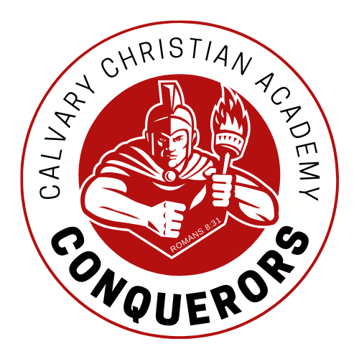
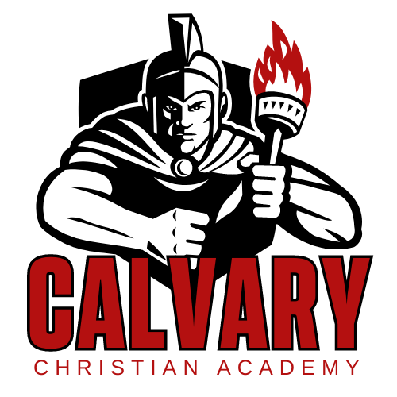

School Name: Calvary Christian Acad.
Team Colors: red/gold/white
Overall Wins ___ Losses ____ Ties ___
ACAA Wins ___ Losses ____ Ties ___ OPPONENT: __________________________
Date: _________
Number | Name | Year | Position | Height | Homeschool
22 | Aden Mickey | 11 | M
21 | Connor Hawn | 10 | D
19 | Jacob Wahlbrink | 10 | D
10 | Paiton Zimmerman * | 10 | F
13 | Everett Cahill | 9 | D | *
12 | William Lane | 9 | F
7 | Gabriel Schroeder | 8 | M | *
26/0 | Nathaniel Fisher | 8 | GK | *
5 | Zion Boone | 8 | M | *
3 | Clayton Ayers | 7 | D
2 | Jackson Suttles | 7 | M
1 | Jacob Anders | 7 | M
25 | Dakota Bonin | 7 | D
18 | Zachary Feaster | 6 | M
15 | Jethro Schroeder | 6 | D | *
14 | Harvey Anderson | 6 | D
17 | Torren Arnold | 6 | D
MGR | Brandon Gosizk | 12 | mgr
 | *Denotes team captain

Head Coach: Daniel Schroeder
Asst. coach: Jonathan martin
Asst. coach:

Official ACAA League Team Roster. to be submitted to the scorer’s table before each game.

